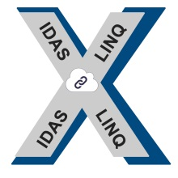IDASLINQ/ CONXTEXT MESSAGING GATEWAY 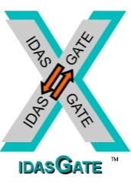 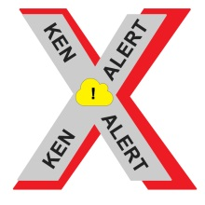  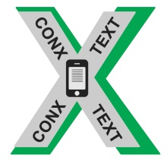
MULTI-FORMAT MESSAGING GATEWAY SUPPORTS LMR/ PAGING/ SMS/ CAPABILITY
Does your facility use EAGL Pagers, Cell phones or VHF/ UHF 2-way radios for Communications?
CONXTEXT supplies connectivity to/ from all of the following protocols:
• SMTP from facility email server accepts desktop messages from users to text to subscribers in the Gateway database
• Program has a built-in subscriber database which accommodates any number of subscribers
• Each sub record can define multiple devices that one input can output messaging to with email (SMTP) input
• Icom IDAS text messaging format supported (aka: IDASMAIL) outputs SDM to an IDAS mobile for transmission
• Kenwood NEXEDGE text messaging outputs to a Kenwood mobile for delivery same as ICOM IDAS method
• SNPP (Simple Network Paging Protocol) supported
• TAP inputs from nurse call systems, HVAC issue alerting from building comfort systems, etc. (TAP concentrator)
• TAP output (like to Zetron or other TAP compliant systems) alpha text alerts pagers 1, 10 or 100 in less than 5 seconds
• TNPP protocol supported; terminal-to-terminal intercom
• SMS text messaging via cellular modem bolt-on
• Web portal for desktop messaging input (comes with a mini HTTP web portal for easy implementation)
• Pages on interval for alarm reporting “heartbeat” receiver systems that are “integrity monitoring” verification
Requirements: Supply a PCI multiple COM port card for I/O port routing (8 ports is typical installation)
Program runs in Windows XP, 7, 8, 10 on any PC Facility full-site license with unlimited users for one price
NO recurring licenses, costs or fees; the facility buys & owns it for unlimited number of users….one time cost!
ENTERPRISE ELECTRONICS 22826 MARIPOSA AVE. TORRANCE, CA 90502
CALL BOB BURCHETT: 310.534.4456

